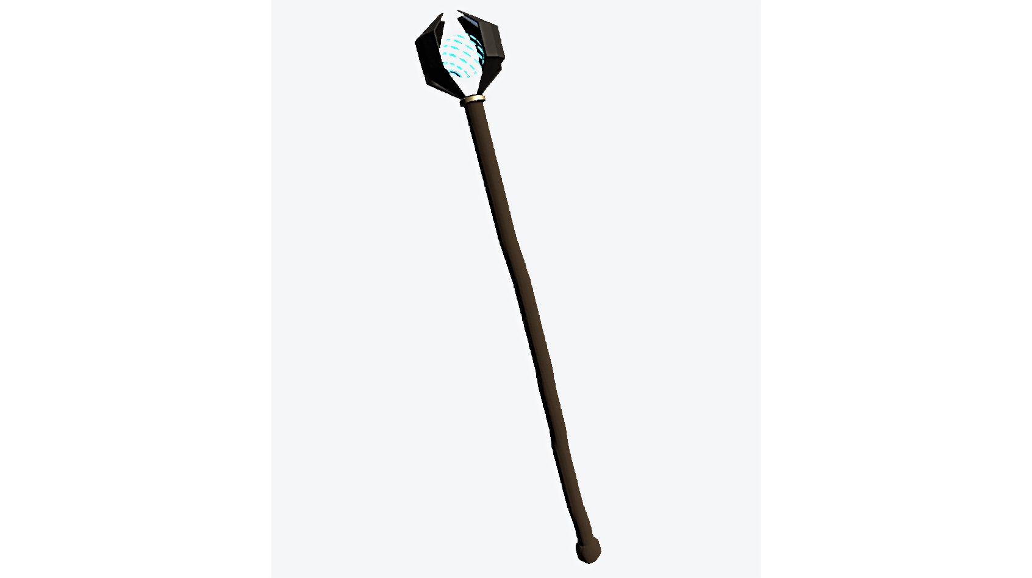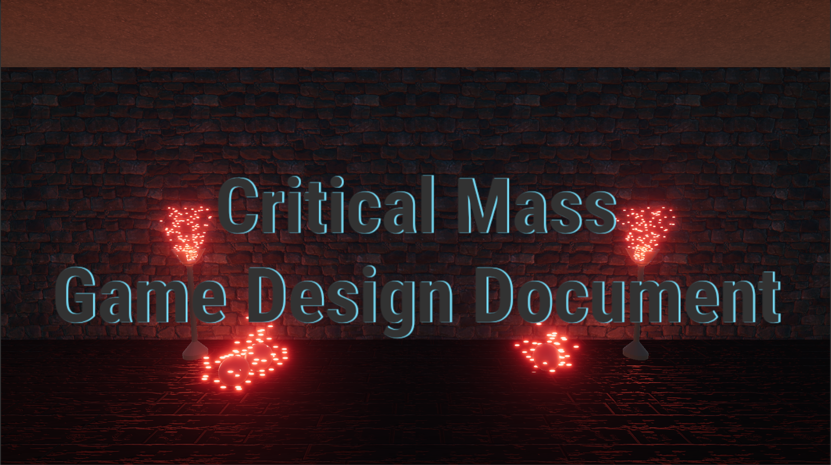

Lenny Gingello



Game Design

## Summary

In Critical Mass the player has abilities granted to them by their school’s magic Arch Staff. Tasked with finding magic crystals and placing them back into their receptacles the player can use the staff to do many things. They can shrink and grow themselves. They can also shrink and grow specific objects in their environment. On top of this they can shrink and store one object in their inventory as well as freeze objects in midair. In order to use these abilities players must have the resource Matter. To gain matter the player must shrink scalable objects in the environment. When the player has matter they can grow themselves and other objects, but when they run out the player can only use the shrink abilities.

## Gameplay

Gameplay will consist of players solving environmental puzzles that challenge the player to use their abilities. Puzzles may consist of players shrinking to get through small crevices, players moving objects, players making objects smaller or bigger to jump on top of them to propel themselves upwards, or freeze objects to create platforms to cross gaps.

The win state of each level is to get the Magic Shard back to the Magic Shard Receptacle. To do this the player needs to solve some environmental platforming and navigation puzzles in order to bring the Shard to the Receptacle.  
 Loss states are directly related to player size or whether or not they fell into chasms in the level environments.

* If a player gets to the maximum size and tries to grow again they’ll pop, losing the level.
* If a player is at the minimum size and tries to go smaller they’ll evaporate, losing the level.
* If a player reaches a platforming section and finds that there is nothing beneath them and falls they will lose the level.

## Mindset

I want the player to play the game at medium pace to slower pace. I want them to feel in control at all times and that after they’ve learned to control the game correctly I want them to feel like they have all of the tools to complete challenges. I also want the player to be able to have fun and experiment with the tools they’ve been given and make crazy things happen! The game should be fun and whimsical.



Technical

## Screens

1. Title Screen
2. Play
   1. Instruction Screens
   2. Level 1
   3. Level 2
3. Quit

## Controls

The player will control the game with the typical **WASD** and aim the camera with the mouse in a standard first-person environment. The player will have two layers of control. The top layer allows the player to interact with the objects in the environment, the Object Layer. In the Object Layer the player uses **right click** to shrink objects and **left click** to grow objects.

The next layer is the Player Layer. To access this layer the player must press the **left control** key and they can use **right click** to shrink themselves and **left click** to grow themselves.

Shrinking an object down to it’s smallest size allows the player to capture the object. To do this the player must keep shrinking (Object Layer, **right click hold**) until it disappears. To **summon** it in the environment the player can use the **F** key on any layer. On the screen the player will see a glowing orange orb constantly pictured in the center. Using the **scroll wheel**, the player can move the orb closer to them or farther away from them. This indicates the placement of the summoned object and when **F** is pressed the object will appear at the orb’s location.

Another option the player has is to **freeze** objects in the environment. To do this the player must press the **E** key while on any layer. If an object is shrunk after it is frozen it will remain frozen when replaced in the environment.

## Mechanics

The main mechanics of the game surround the player being able to interact with and change objects in the environment. The main two actions the player can make are shrinking and growing. The control layers the players are on decide whether they shrink themselves or an object in the environment.

To use the growing and shrinking abilities the player needs to absorb the Matter resource. When a player has matter they can grow objects into the sizes they need and grow themselves. To get Matter players must shrink scalable objects in the environment.

Secondary mechanics surround changing the states of the objects that the player interacts with. The first of these mechanics is the freezing mechanic in which the player can freeze a scalable object in mid air creating a barrier or most usably a platform. The second of these mechanics is the capturing and summoning mechanics. If an object is shrunk down far enough, and there already isn’t one in their inventory, the player can add scalable objects to an inventory and summon them later at a location of their choosing.



Level Design

## Themes

1. Magical School dungeon/basement
   1. Mood
      1. Warm, passive tension, anxious, need for movement
   2. Objects
      1. *Interactive (Physics Objects)*
         1. Scalable objects
            1. Boxes
         2. Objective Objects
            1. Magic Shard Receptacle
            2. Magic Shard
      2. Environment (Static Objects)
         1. Floor
         2. Walls
         3. Roof
         4. Wall caps
            1. Columns to round off the wall edges

Level Design

Level 1 Level Layout

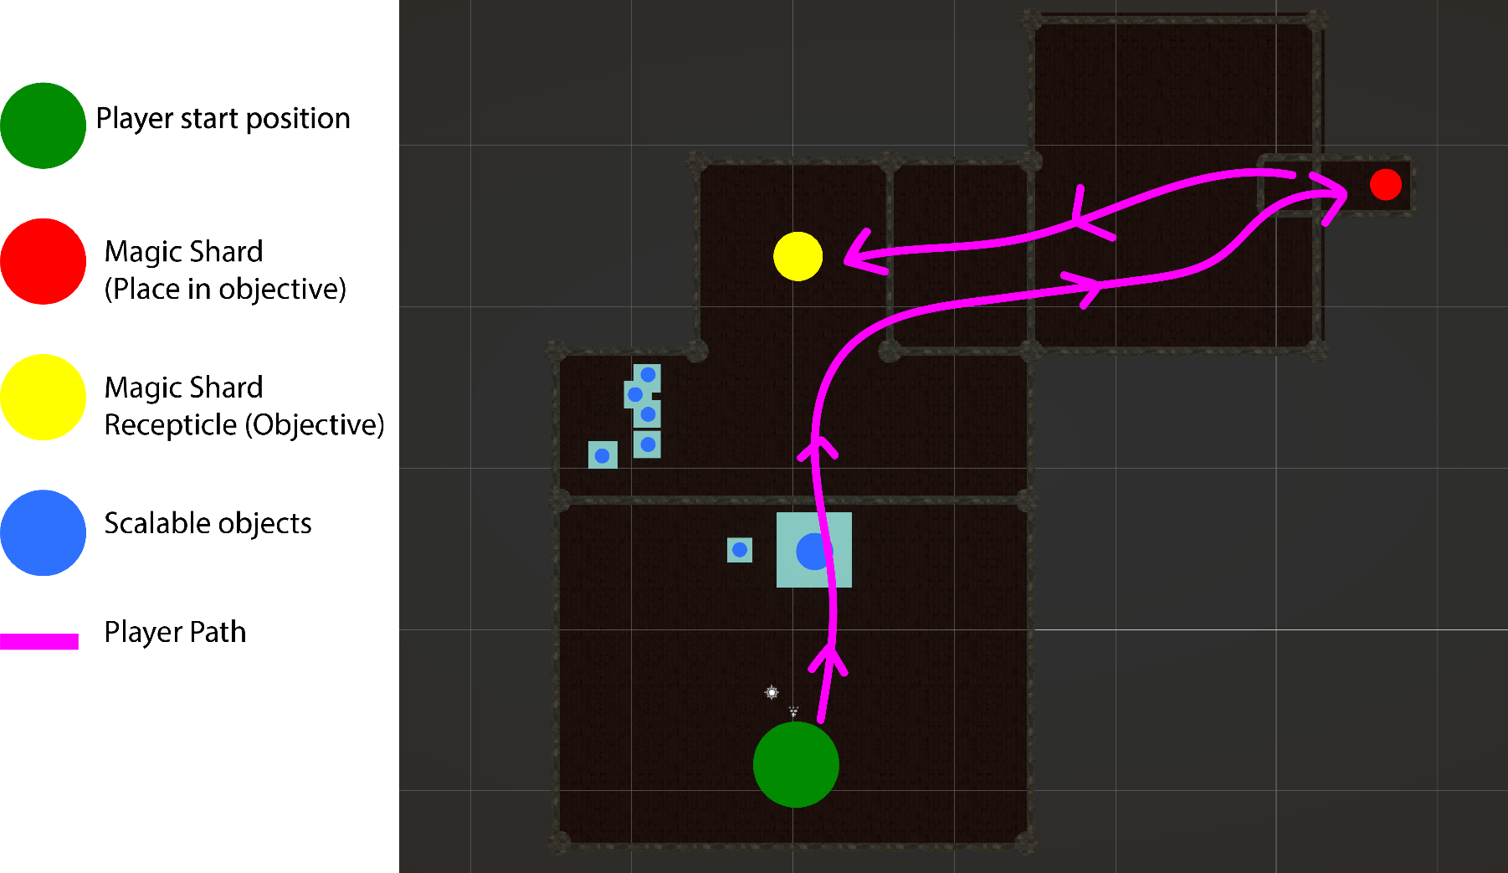

Level Design

Level 2 Layout

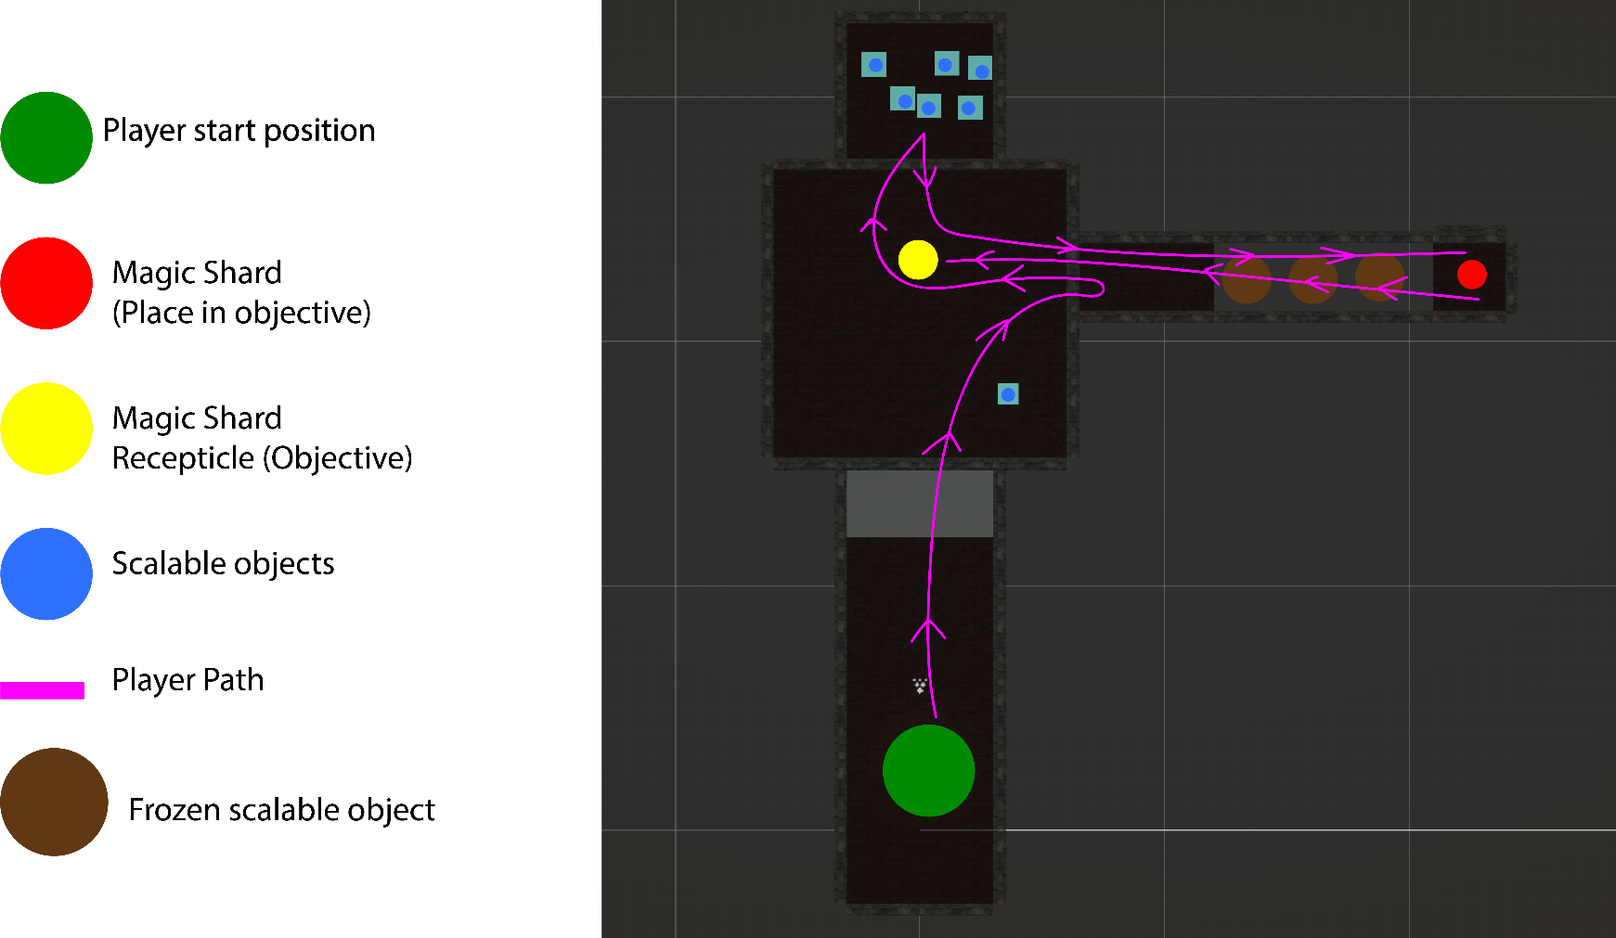

QA Test Plan

*Done according to outlines provided in Principles of Game Design*

**INFORMATION**

Game Title: Critical Mass

Contact: Leonard Gingello

**INTENT OF TEST**

* To conduct usability testing

**GAME SET UP**

* Executable found in builds folder of repository
  + CriticalMassVx.exe (CriticalMassV2.exe, CriticalMassFinal.exe)
* Set at 1920x1080 and graphics at default (Ultra) settings

**TESTING SCRIPT**

* “Have you played this game before?”
  + If yes, what is the testers experiences previously?
  + If yes, when did they play last?
* Introduce the main mechanics and controls
* Allow them to play the game
* Note if the tester routinely asks for clarification
* When finished have the tester fill out the response form

**FEEBACK QUESTIONS (For the form)**

* Were the controls and mechanics easy to understand?
  + Yes
  + No
  + Other, explain
* Was the objective clear?
  + Yes
  + No
  + Other, explain
* Did you encounter any bugs?
  + Short form response
* Did you enjoy the experience?
  + 0 – 10 Scale
* General feedback?
  + Long form response

QA Test Results

Early informal testing led me to believe while the initial concept was interesting and functional that there was not enough there mechanically to make something interesting. This lead to the creation of the different freezing and summoning mechanics with emphasis on the new platforming section in the second level.

Further on, other than that players thought that the concept was easy to understand and interesting.

1. Players routinely rated their enjoyment factor from between 6 and 8
2. Players found that at first the controls were hard to understand and grasp fully they were able to get the handle of the quickly
3. Players encountered one bug where they were unable to trigger the release of a player animation which resulted in the game being stuck and players unable to use abilities
4. Players were routinely able to determine what the actual objective of the game was.



Graphics

## Style Attributes

I plan to go with a low poly minimalist style due to time limitations and the necessity to work the majority of my time on mechanics and gameplay. The environment will be textured as well as possible with some semi-realistic textures, but the actual models will be low poly.

All meshes will be low poly to allow for players to easily identify shapes and avoid any clutter on screen that may distract and confuse players when navigating the world space.

Visual feedback will be mostly done through particle effects on intractable objects. Visual feedback also will extend to the shrinking and growing of other objects in the environment. There must also be some animation done for the interactions the player has in the environment

## Graphics (Meshes) Needed

1. Environment
   1. Scalable Objects
      1. Cubes mostly
   2. Stairs or ramps
   3. Walls
   4. Floors
   5. Wall Caps
   6. Magic Shard Receptacle
   7. Player Staff

Graphics

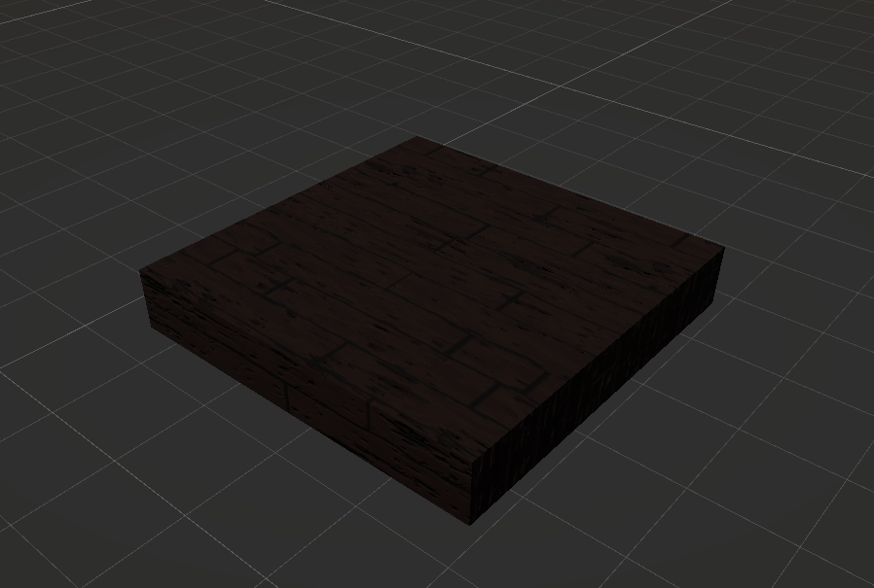1x3 Wall Flooring

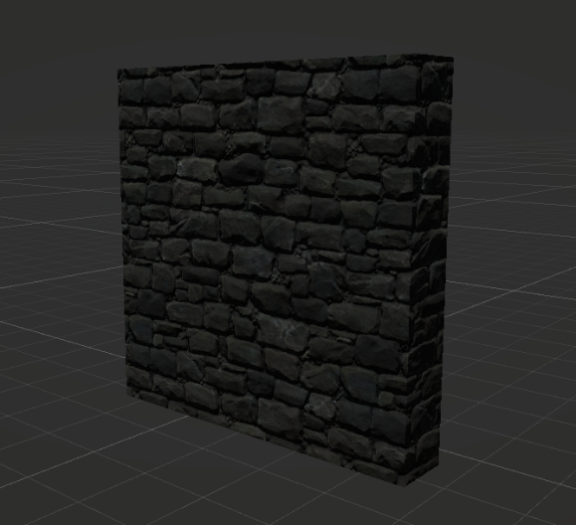Wall End Caps Roof

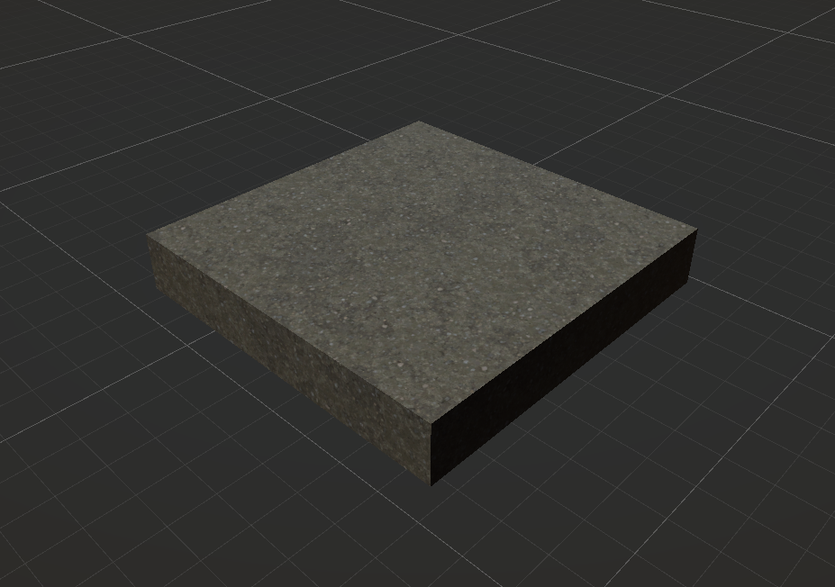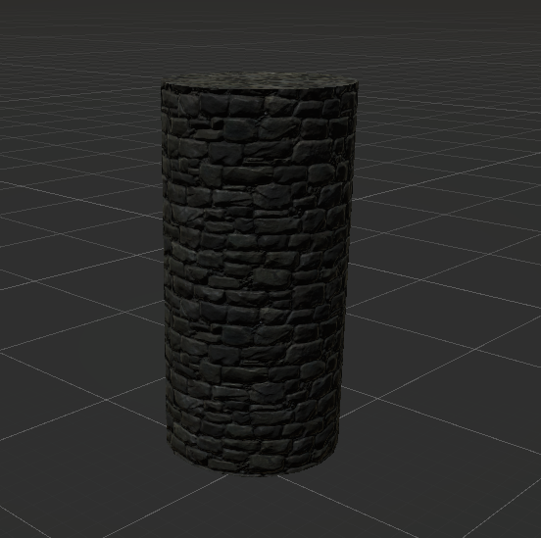

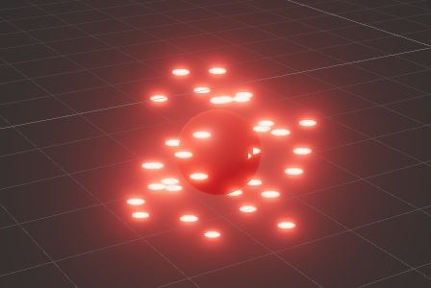Magic Shard Receptacle Magic Shard

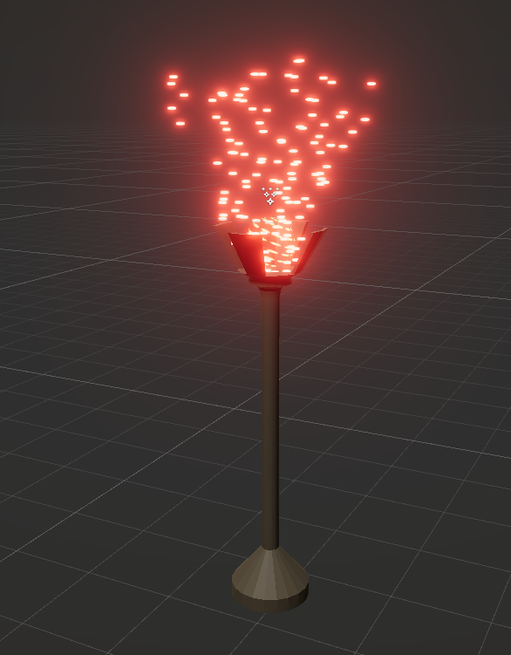

Graphics

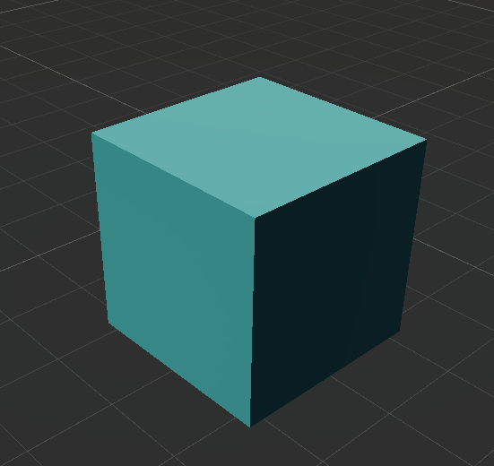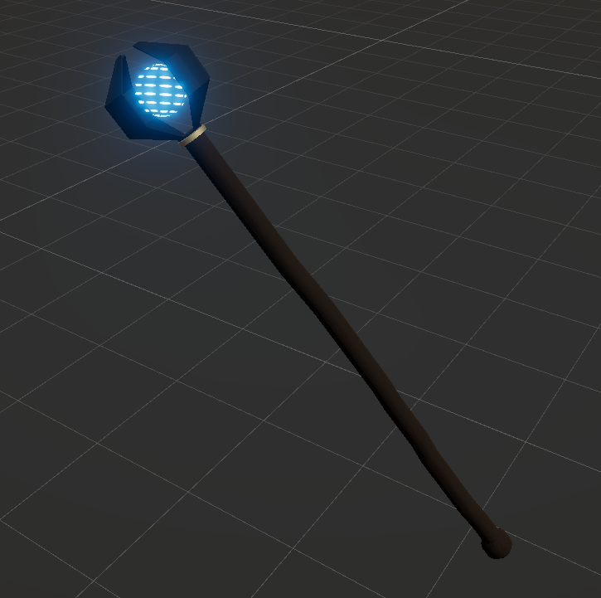Player Staff Scalable Object 

Sounds/Music

## Style Attributes

The sound effects I choose need to encourage an atmosphere of tension to add to the fact that the player isn’t in any immediate dangers from anything except for the environment. Due to the lack of any sort of perceived ominous action on behalf of the game towards the player this tension added to the game from the music will be important to encourage the player to keep moving and complete the level.

It is also vital to have great and identifiable sound effects for all of the physics and size based mechanics to add to feedback and provide a non-visual way for the player to find out if something is happening.

## Sounds Needed

1. Effects
   1. Shrinking sound
   2. Freeze object sound
   3. Growing sound
   4. Summon object sound
   5. Death sound
2. Feedback
   1. Audio feedback when performing actions
      1. Growing and shrinking sound for objects
      2. Growing and shrinking sound for players
   2. Noise when the player dies
   3. Summon object noises when the player takes an object out of their inventory.

## Background Sounds Needed

1. Background ambiance noise that gives the sense that the player is deep below ground and in a dank castle basement.



**Schedule**

*Systems and Mechanics QA will be done at different times when it seems fit to in order to test new functionality.*

1. Create a player movement system
   1. Physics based player movement
      1. First person
      2. Jumping ability who’s height and speed depends on mass
   2. Create basic environment
      1. Rectangular room
2. Create the system for which size is implemented in the game
3. Implement rudimentary visual and audio feedback
4. Create the interactable objects within the world space
5. Create a modular sandbox environment to create and test puzzles
6. Design levels based on the experiments done in the sandbox environments
7. Continue to polish movement systems
8. Finalize visual and audio feedback
9. Add polish elements
   1. Music
   2. Refined menus

Risks

The risks with this project revolve around the mass and size mechanics and their scope. Have I done the research and do I have the skills necessary to pull this off in a polished state? Will I have enough time to create this competently? Can I design more mechanics around the shrinking and growing to make a better experience? This game will certainly present some design challenges. Do I believe that I can design enough puzzles to create a good experience? I’m also just worried about my overall competency. This is my first year learning to use Unity in 3D on more than just a surface level. As the semester goes on I know my skills will improve, but will it be fast enough improvement to make this project better?